Exercise No:2

Date:10/10/2020

**Aim:**

To create a python program to find the occurrences of an element in the list.

**Program:**

def countX(lst,x):

count=0

for i in range(0,len(lst)):

if(x1==lst[i]):

count=count+1

return count

lst1=[]

n=int(input("Enter number of element:"))

for i in range(0,n):

no=int(input())

lst1.append(no)

x1=int(input("Enter the element to search:"))

y=countX(lst1,x1)

print(y)

**Link:**

[**http://103.53.53.18/mod/vpl/forms/submissionview.php?id=230&userid**](http://103.53.53.18/mod/vpl/forms/submissionview.php?id=230&userid)

**Output:**

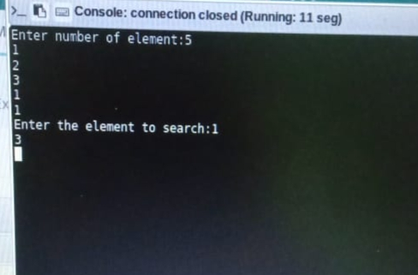

**Result:**

Thus, the program is executed and output of occurrence count Is obtained.